sortApp

User Guide

June 19, 2017.

Table of Contents

Introduction 1
Getting Started 2
System Requirements 2
Quick Start 2
Home Page 3
Sorting Menu 3
History Menu 6

Introduction

The sortApp application takes random numbers provided by end user. And provide sorted number with required statistical data.
Once code is setup(Code Setup Guide). This document will provide instructions for accessing the application and use its core functionalities.

Getting Started

System Requirements

Desktop
System Browser (Google Chrome Version 57 preferred)

Quick Start

User can access sortApp Web based UI from below URL

http://localhost:8080/sortui/#!

Home Page

To Home Page of application has brief introduction to sorting.

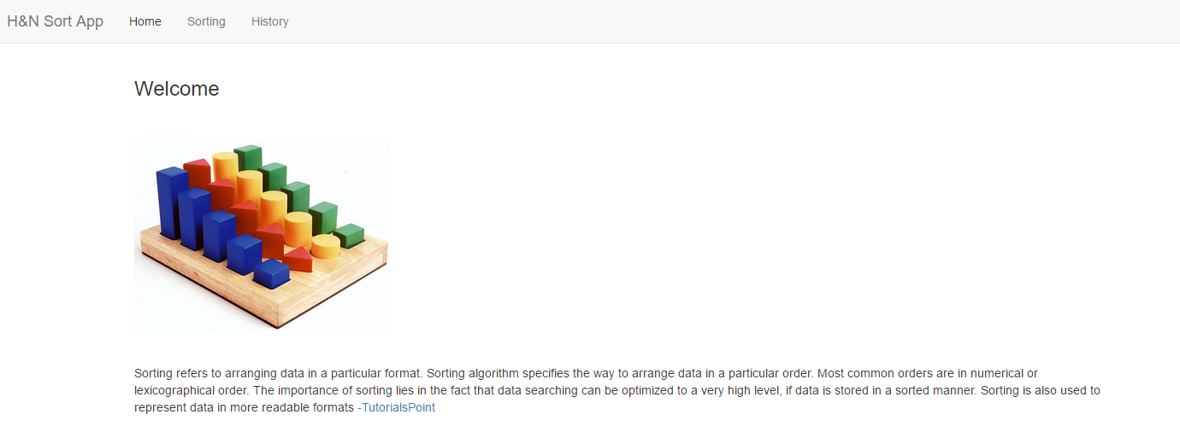

Sorting Menu:

This menu provides major functionalities of App. In this menu, user can provide list of numbers required to be sorted.

List is required to be entered in text area separated by new line.
Minimum two valid integer are required for sorting.
Once number entered, user can click on Sort Number button. And Sorting details will be shown accordingly.

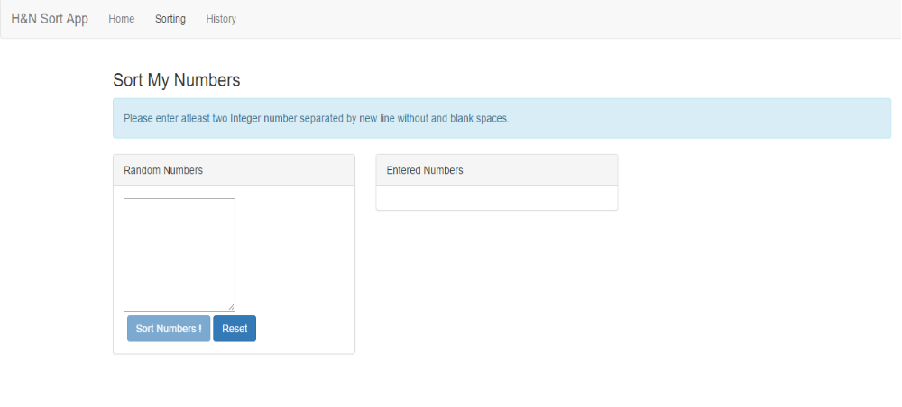

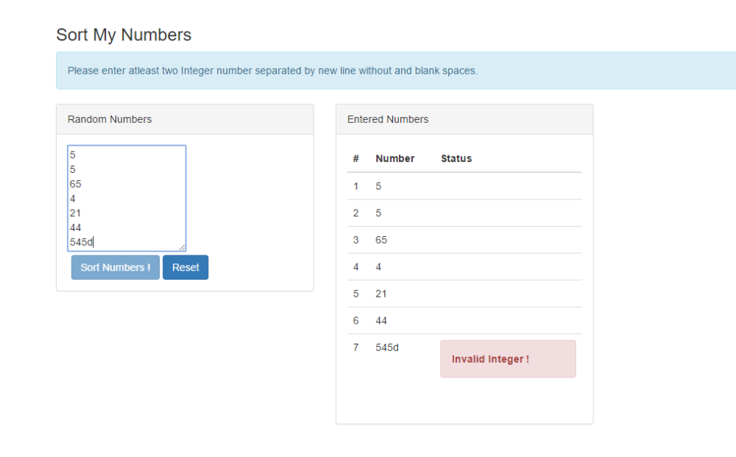

Process Again button can be use to reset data again for next sorting.
In between Reset button can be use to rest data.
Go to History Button is used to check data available in History Menu

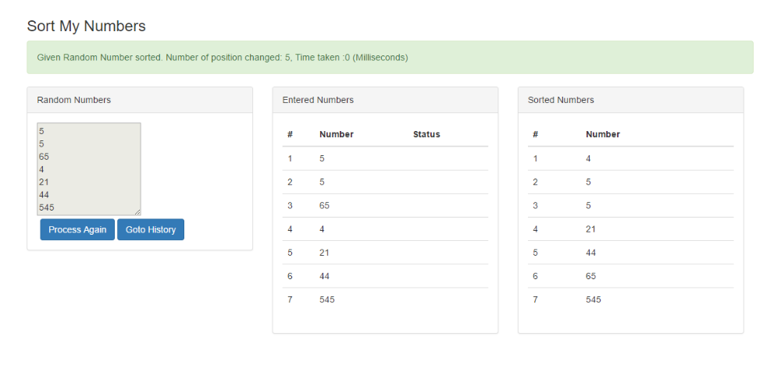

History Menu:

This menu provides past sorted data stored in MySQL.
User can see statistical data for each sorting.

